Exercise: CI/CD with Jenkins
Exercises for the DevOps for Developers module @ SoftUni

Install Jenkins
Our first task is to install Jenkins on our machines.
In order to do that, follow this link: https://www.jenkins.io/download/ and chose the package that is suitable for you and your machine.
The installation for the different operating systems and their distributions are different. You can find the instructions that you need here: https://www.jenkins.io/doc/book/installing/. Simply chose your OS and follow the instructions.
After you have installed Jenkins, follow the Post-installation setup wizard in order to start using Jenkins. Without completing the steps from it, you won't be able to use it. This is a one-time setup, so don't worry – you won't need to complete those steps each time you want to work with Jenkins.

Configuring Jenkins with Docker

CI Pipeline – "Student Registry" App

Step 1: Run the App Locally
We have the "Student Registry" Node.js app in the resources. Your task is to create a CI workflow with Jenkins to start and test the app on three different versions:
Let's first start the app locally in Visual Studio Code. To do this, you should open the project, open a new terminal from [Terminal] [New Terminal] and execute the "npm install" and "npm start" commands:
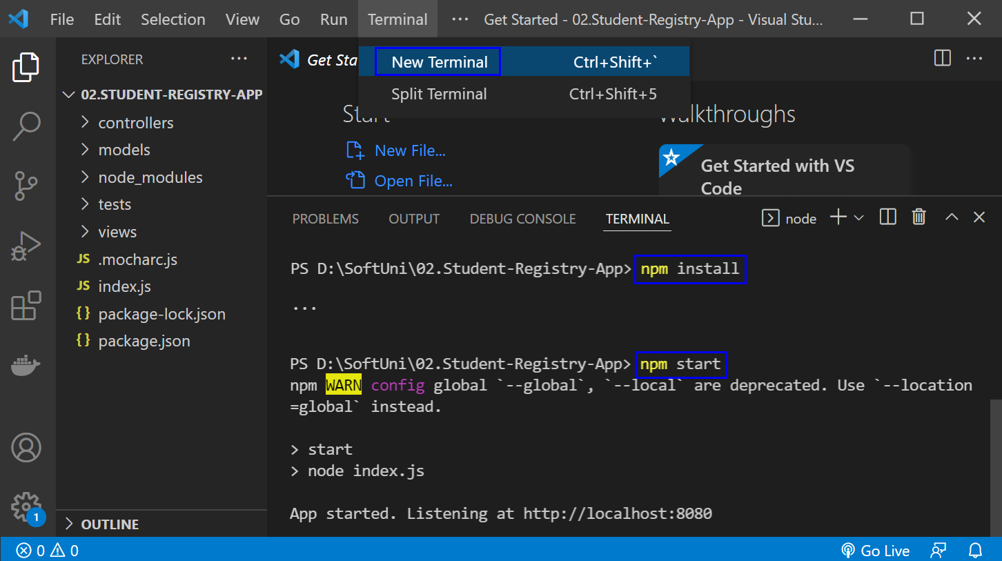
The "npm install" command installs app dependencies from the package.json file and "npm start" starts the app. You can look at the app on http://localhost:3030:
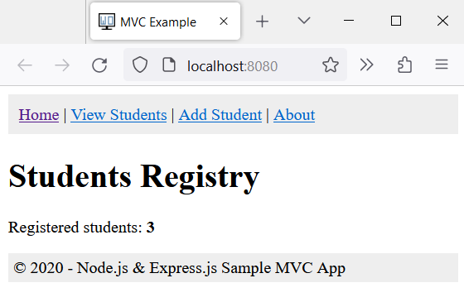
Then, you can return to Visual Studio Code, open a new terminal with [+] and run "npm test" to run the app tests. They should be successful:
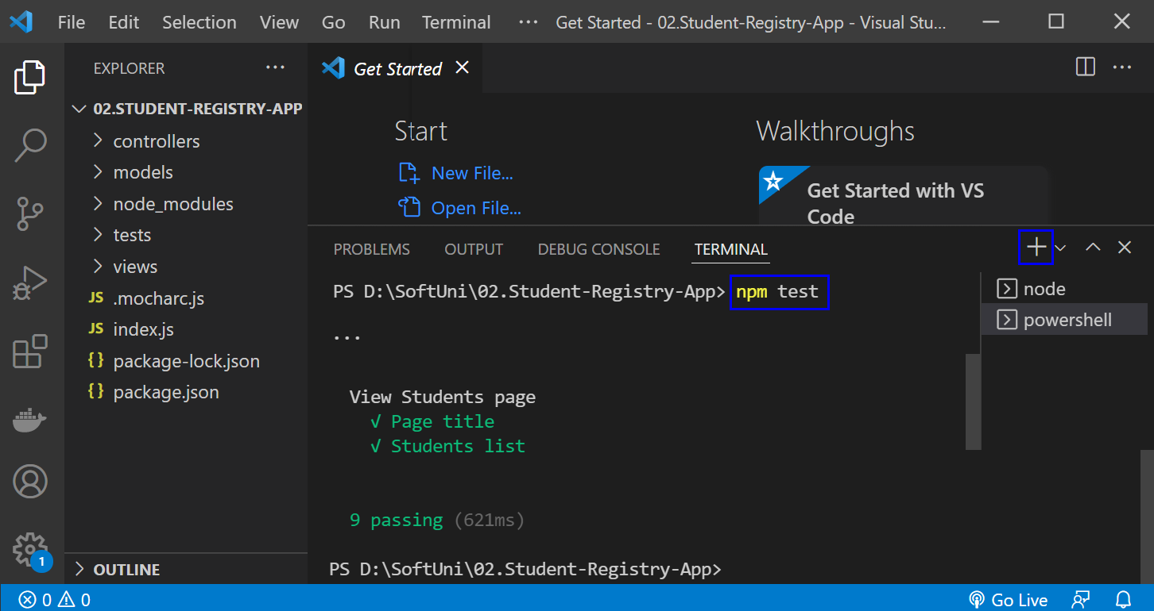
NOTE: if the app was not started, tests would fail because these are integration tests and are executed on the running app.

Step 2: Create a GitHub Repo
Now you should upload the app code to GitHub.

Step 3: Create a New Job
Now, let's access Jenkins. Open the Jenkins interface in a web browser. This is usually at http://localhost:8080, but it depends on the port that you had set up during the installation. Let's create a new job by selecting [New Item] from the Jenkins dashboard.
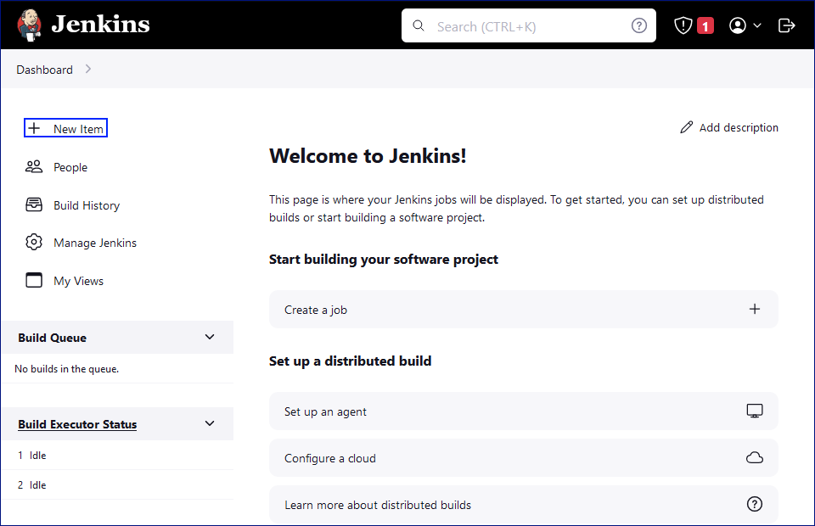 We will enter a name for the job "Student Registry App", chose [Freestyle Project] and we should click on the [OK] button.
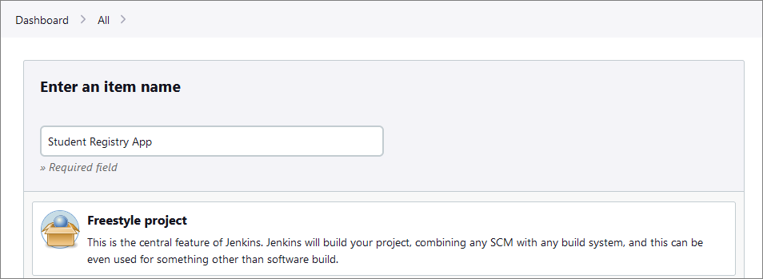

Step 4: Source Code Management
In the job configuration, go to the Source Code Management section.
Select [Git] and enter the repository URL.
After that, click on the [Save] button.
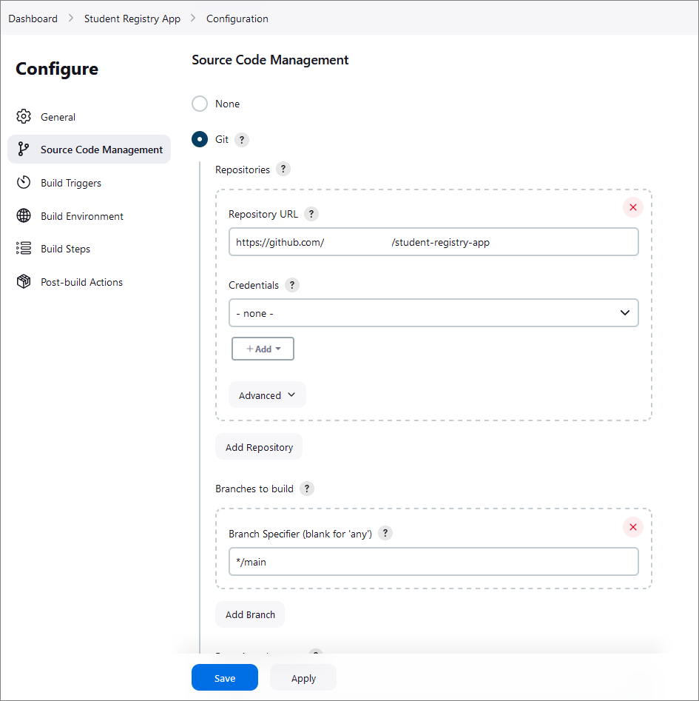

Step 5: Build Triggers
Setting up build triggers in Jenkins to initiate builds on commits to the GitHub repository involves configuring a webhook in GitHub. This webhook will notify Jenkins each time a commit is pushed to the repository, triggering a build automatically.
To do that, we have to configure webhooks in GitHub and configure the Jenkins job.
First, navigate to the GitHub repository that is used for the application. Click on the Settings tab in the GitHub repo. In the settings menu, find and click on Webhooks. Click the [Add webhook] button.
The webhook settings should be the following:
- Payload URL: Enter your Jenkins server's URL followed by /github-webhook/. For example, http://localhost:8080/github-webhook/.
- Content type: Choose application/json.
- Secret: Optionally, you can set a secret token for additional security (make sure to remember this as you will need it in Jenkins).
- Which events would you like to trigger this webhook?: Select Just the push event.
- Active: Ensure this checkbox is selected.
Finally, click on the [Add webhook] button to save the settings.
NOTE: For now, our Jenkins server is not on a public IP address, so we are going to use a tunneling service to expose our local Jenkins server to the Internet temporarily. Here's how to do it:
- Download and run ngrok:
  - Download ngrok and run it on your machine.
  - Use the command ngrok http 8080
  - ngrok will provide you with a public URL (e.g., http://abc123.ngrok.io).
- Update Webhook in GitHub:
  - Use the ngrok URL followed by /github-webhook/ as the payload URL in the webhook settings on GitHub.
- Keep ngrok running:
  - Ensure that ngrok is running whenever you want GitHub to trigger Jenkins.
With that, we have set up GitHub to notify Jenkins for each new commit.
Now, let's modify our Jenkins job to trigger on GitHub webhook notifications.
To do that, go back the Jenkins dashboard and open the job that we created for the application. Click on Configure and select Source Code Management again.
This time, in the Build Triggers section, select GitHub hook trigger for GitHub hook trigger for GITScm polling.
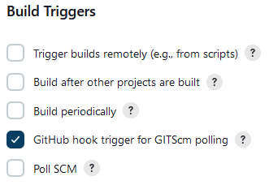

Step 6: Build Steps
Now it's time to add build steps to execute our commands. In our case, this will be the npm install and npm test commands.
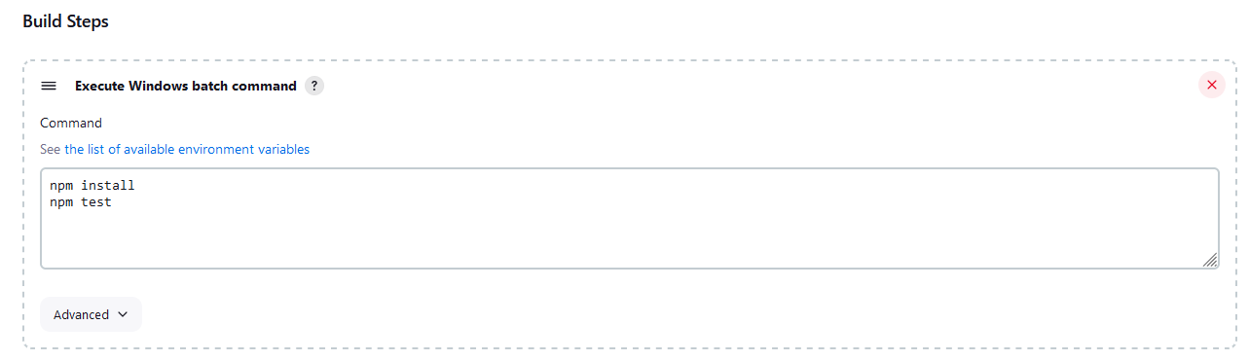

Step 7: Configure Jenkins with Docker
Now let's modify our Jenkins's job to build and push Docker images.
Place the provided Dockerfile in the root of the directory of the repo. Then, go back to the job configuration and add the following commands in order to
docker build -t {your-dockerhub-username}/{app-name}:{tag} .
echo "$DOCKER_PASSWORD" | docker login --username {your-username} --password-stdin
docker push {your-username}/{app-name}:{tag}
The settings in the Jenkins dashboard should look like this:
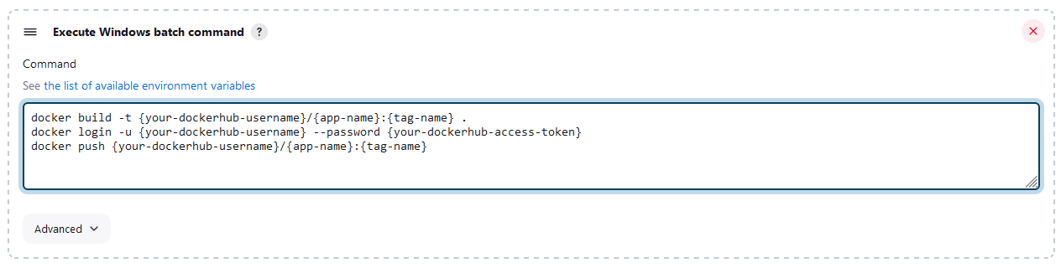
NOTE: In order for Jenkins to successfully access your DockerHub account, you should create a DockerHub access token and use it for the script.
NOTE: Ensure that the Jenkins server has Docker installed and that the Docker daemon is running.
NOTE: The Jenkins user must have the necessary permissions to execute Docker commands.

Step 8: Test the CI Pipeline
After completing those steps, we are ready with the CI pipeline and it's time to test if it's working as expected.
First, make a minor change in the app code and commit and push this change to the repo, holding the application. This will trigger the Jenkins job and in the console output we can check if there are any errors.
If no errors have occurred, we can check the Docker Hub, too, to verify that the image is pushed with the correct tag.

CD Pipeline – "Student Registry" App
Setting up the CD Pipeline with Jenkins and Docker is pretty straightforward. However, we will need a docker-compose file for the app, we will have to configure the Jenkins job for deployment and last, we'll verify our setup.

Step 1: Docker Compose Setup
Examine the docker-compose.yml file in the resources. Add to the placeholders your username, the name of the application and the tag name. They must be the same as the ones from the previous task.

Step 2: Jenkins CD Pipeline Configuration
Now we will create a new Jenkins job that is specifically for our deployment.
This time we will add deployment steps. We will add them the same way we added the build steps. The configuration should look something like this:
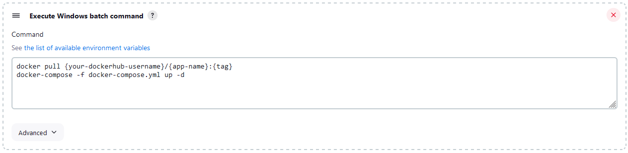
NOTE: We should add the GitHub repo again.

Step 3: Add Post-Build Actions
Now we have to set up the job to automatically deploy after a successful build. We will have to configure the CI job again – this time we will add a post-build action to trigger the CD job:
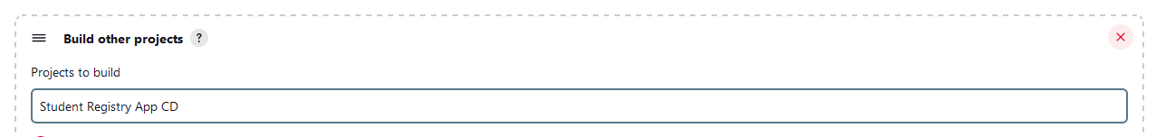
Choose the Trigger only if build is stable option as this will ensure that the CD job will only run if the CI job succeeds without any errors.
This way we linked our CI and CD jobs and whenever our CI job (build and test) completes successfully, it will automatically trigger our CD job, which takes care of deploying our application using Docker.

Configuring Jenkinsfile

CI Pipeline – "Student Registry" App

Step 1: Run the App Locally
As always, you should run the app locally to ensure that everything is working correctly.

Step 2: Create a GitHub Repo
Create a new GitHub repo and upload the app code to it.

Step 3: Create a New Job
Now, let's create a new job by selecting [New Item] from the Jenkins dashboard. Choose Pipeline and give it a meaningful name, after that click on the [OK] button.
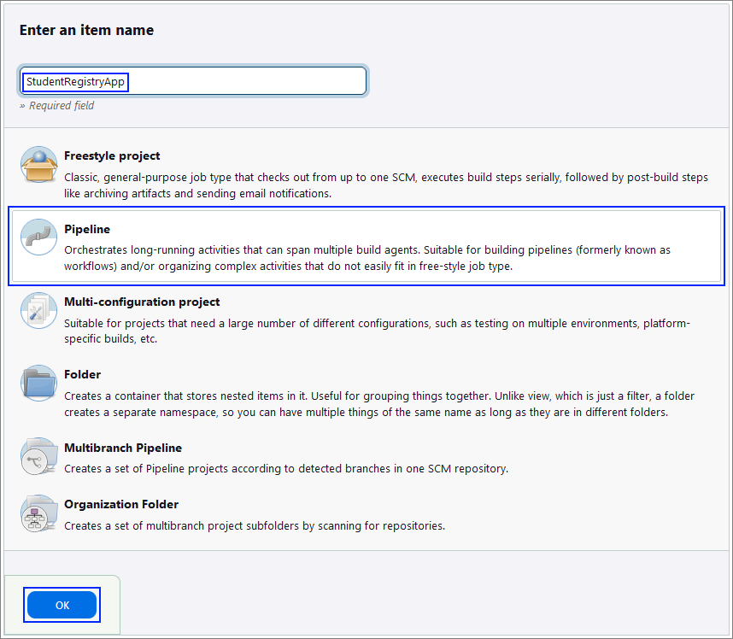

Step 4: Create the Jenkinsfile
Best practice for using a Jenkinsfile is to keep it within your source control repository.
This approach has several advantages like version control and branch specific pipelines. Placing the Jenkinsfile in the repository, means that it will be versioned alongside your application code and the versions can later be reviewed. Also, you can have different Jenkinsfile versions in different branches, which allows for testing changes to the build process in a feature branch before merging them to your main branch.
The Jenkinsfile should contain steps for:
- Checking out the code
- Setting up Node.js
- Installing dependencies
- Starting the application
- Running tests
Create your file and upload it to your GitHub repository, containing the code for the application.

Step 5: Configure the Job
Now, let's go back to Jenkins to finish configuring your job.
First, in the General section give a Description for the job.
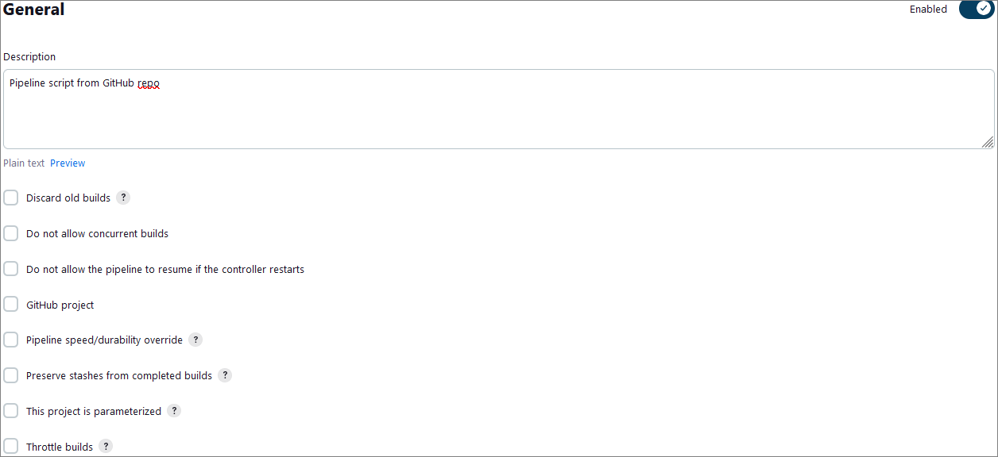
Then, scroll down to the General section In the job configuration, and from the Definition dropdown menu, select the Pipeline script from SCM option.
After that, select Git as the SCM and enter your GitHub repository URL.
Under Branches to build, enter the branch name that contains your Jenkinsfile.
Under Script Path, ensure it points to your Jenkinsfile (for example, type in Jenkinsfile if it's in the repository root).
Your configuration should look like the images below:
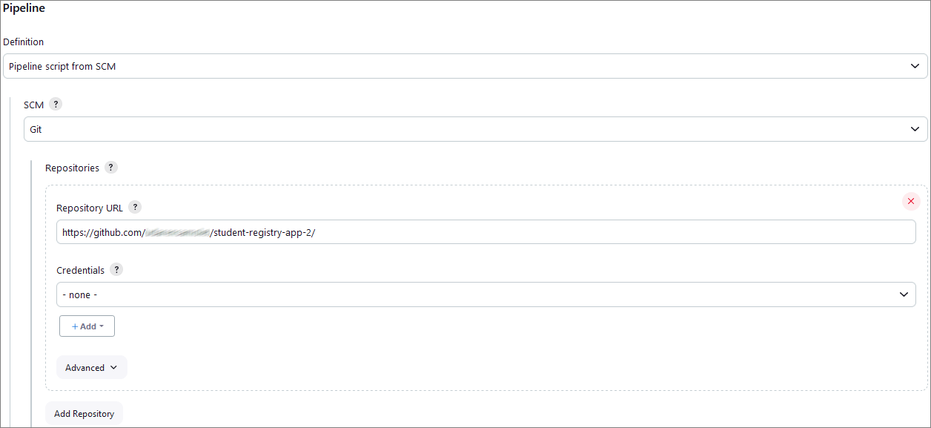
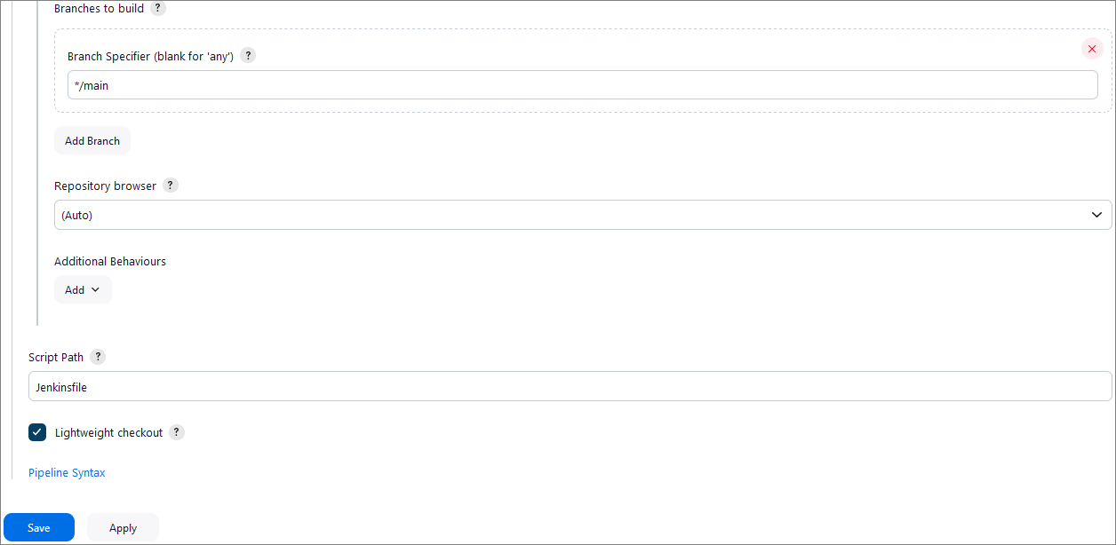
Finally, click on the [Save] button.

Step 6: Test the CI Pipeline
After completing those steps, we are ready with the CI pipeline and it's time to test if it's working as expected.
First, click on the Build Now option to start a new build manually.
You can monitor the build progress by clicking on the build number and then Console Output.
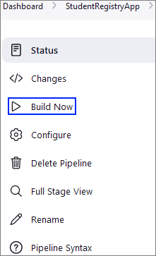
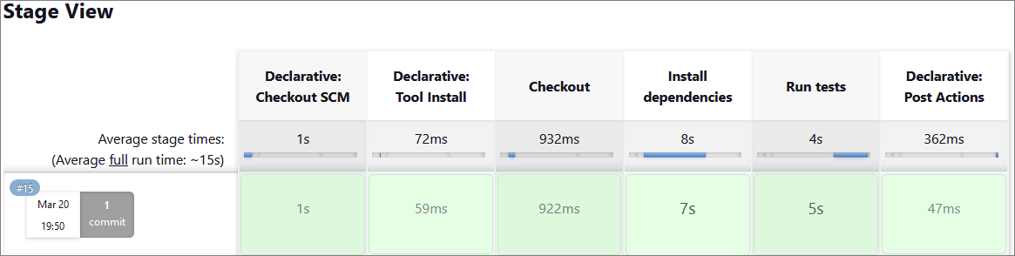
You can try and set up yourself Webhooks for automatic triggers just like we did in the previous task, so that each new commit triggers Jenkins to build automatically the pipeline.

"HouseRentingSystem" App – ASP.NET Core MVC app

Step 1: Run the App Locally
We have the "HouseRentingSystem" ASP.NET Core MVC app in the resources which has some unit and integration tests already. Your task is to create a CI workflow with Jenkins to start and test the app.
It's a good practice to first start the app locally in Visual Studio, in order to be sure everything works properly and as expected.
Open Visual Studio and from there navigate to the Tools menu. Select NuGet Package Manager and select Package Manager Console:
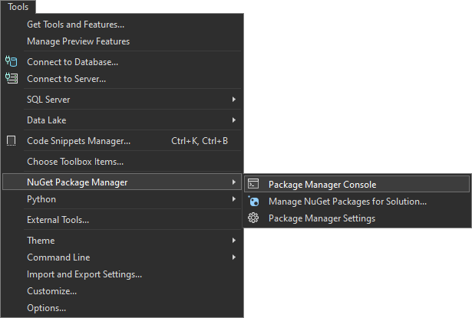
Let's first build the application by using the dotnet build command:
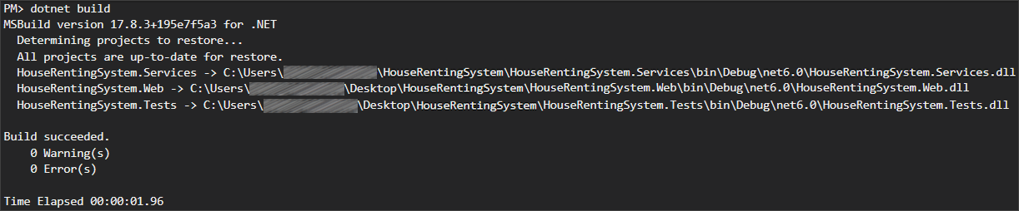
After you have ensured that the build was successful, you can run the tests, too, by using the dotnet test command:
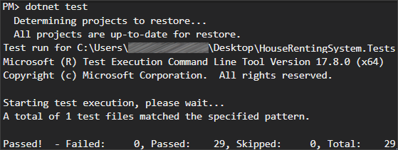
NOTE: Visual Studio has built-in test runners that allow you to run your tests directly from the IDE. This is the simplest way to execute tests if you're already working within Visual Studio. However, it's better to get used using the console.
After we have ensured that the tests run successfully, we can proceed with the next step.

Step 2: Create a GitHub Repo
Now you should upload the app code to GitHub. Try using the CLI and the commands from the previous task to add the code to the repo and commit it.

Step 3: Configure Tools in Jenkins
To run an ASP.NET Core MVC app in Jenkins, you need two plugins: Git and MSBuild.
Usually, Git is being installed when you are configuring your Jenkins installation and we already used it in the previous task.
Let's focus on configuring the MSBuild plugin.
Go to Manage Jenkins menu and select Plugins. From the menu on the left, select Available plugins and type MSBuild in the search field. Select the plugin and click on the [Install] button:
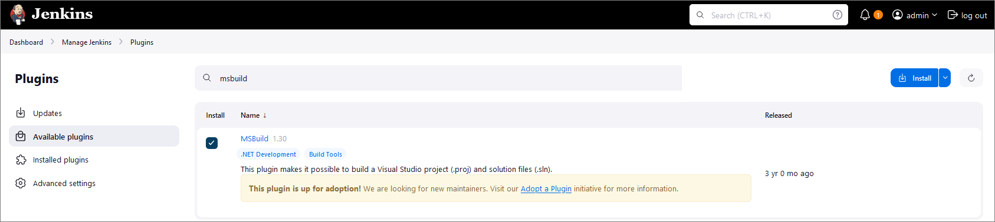
Once you have the needed plugin installed, go back to Manage Jenkins and select Tools. Scroll down to find the MSBuild installations section and click on [Add MSBuild] button:
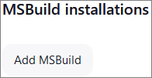
Give a meaningful name to your MSBuild and provide the path to your MSBuild.exe file.
NOTE: MSBuild.exe is the command-line tool for Microsoft Build Engine, which is used to build applications. This engine uses XML-based project files to compile and link the code, manage project dependencies, and execute other build tasks. It's a vital component of the .NET framework development process and is also used in building software projects in other languages. MSBuild comes included with several Microsoft products, including Visual Studio. Usually, the path to your MSBuild.exe file is something like C:\Program Files (x86)\Microsoft Visual Studio\2022\BuildTools\MSBuild\Current\Bin\MSBuild.exe.
The configuration should look like the image below:
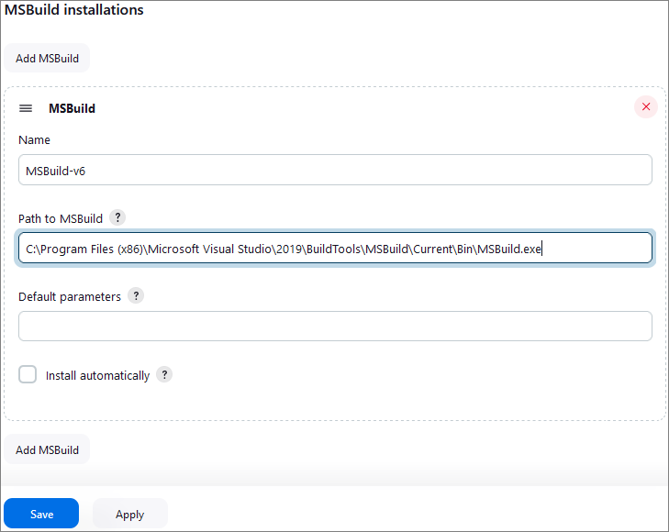
Finally, click on the [Save] button.

Step 4: Create and Configure a New Job
Open the Jenkins interface in a web browser.
Create a new job by selecting [New Item] from the Jenkins dashboard. Choose Pipeline and give it a meaningful name, after that click on the [OK] button.
Next, on the General section, type in a proper description.
Select GitHub project as the Source Code Management option and input the URL of your repository.
If you want, you can play around a little bit and add a build trigger, as you already know how to do that.
Go to the Pipeline section and select Pipeline script from SCM as you already know this is the best practice for where to keep the Jenkinsfiles. Configure the path to the repository and to the Jenkinsfile. The steps are the same as in the previous task.

Step 5: Create the Jenkinsfile
The Jenkinsfile should contain steps for:
- Restore
  - Restore the NuGet packages needed for the project to ensure all dependencies are downloaded and available during the build process.
- Build
  - Build the project to check for compilation errors.
- Test
  - Execute the tests to ensure that they're running properly
Create your file and upload it to your GitHub repository, containing the code for the application.

Step 6: Test the CI Pipeline
After completing those steps, we are ready with the CI pipeline and it's time to test if it's working as expected.
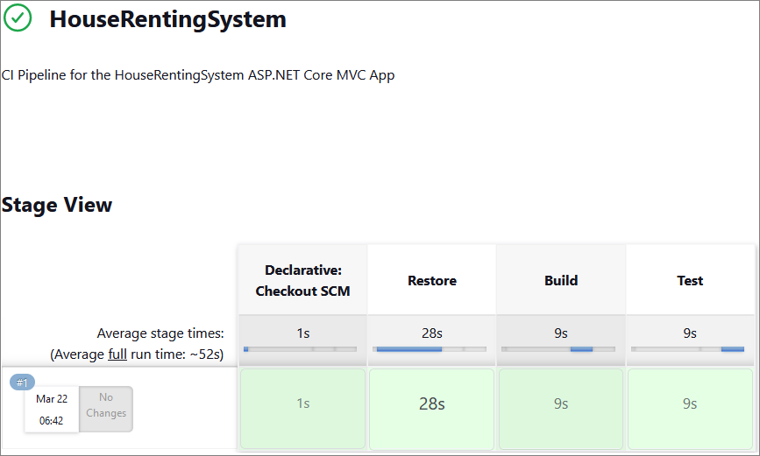
First, click on the Build Now option to start a new build manually (in case you haven't configured the build triggers).
You can monitor the build progress by clicking on the build number and then Console Output.

Selenium IDE

Step 1: Run the App Locally
We have the "SeleniumIde" solution in the resources which has one test projects already. Your task is to create a CI workflow with GitHub Actions to run the tests automatically.
It's a good practice to build the solution locally in Visual Studio, in order to be sure everything works properly and as expected.
Open Visual Studio and from there navigate to the Tools menu. Select NuGet Package Manager and select Package Manager Console:

Let's first build the application by using the following command:
dotnet build
After you have ensured that the build was successful, you can run the tests, too, by using the command below or just by clicking on the [Run All Tests in View] button in the Text Explorer.
dotnet test
After we have ensured that the tests run successfully, we can proceed with the next step.

 | You have to be sure that the Chrome and ChromeDriver installed on your local machine are one and the same major version. For example, ChromeDriver v.125 won't work with Chrome v. 127!

Step 2: Create a GitHub Repo
Now you should upload the solution to GitHub.
It's a good practice to start using the console and not the interface of GitHub, in case you haven't started doing so yet.
If you don't have Git already installed on your machine, follow the provided installation instructions from the resources.
Try using the following commands in order to initialize a repository in your project directory, add the code to the repo, commit and push:
git init
git add .
git commit -m "Initial commit"
git remote add origin https://github.com/{name-of-your-repository}
git push -u origin main
After running the commands, check you GitHub repo – the application code should be visible.

Step 3: Add Changes to Test Files
Before creating the workflow file, we have to make some adjustments in the .cs files. This is needed due to the fact that the default GitHub runner does not have Chrome installed. We will take care of this in the workflow, but we also need the prepare the tests to run Chrome in a headless mode within the CI environment.
In order to do that, go to the SetUp() method of the project and modify it so it looks like below:
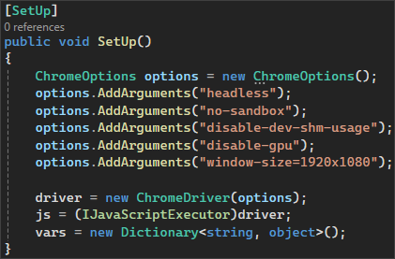
Don't forget to commit and push the changes from the file.

Step 4: Configure Tools in Jenkins
To run an ASP.NET Core MVC app in Jenkins, you need two plugins: Git and MSBuild.
Usually, Git is being installed when you are configuring your Jenkins installation and we already used it in the previous task.
Let's focus on configuring the MSBuild plugin.
Go to Manage Jenkins menu and select Plugins. From the menu on the left, select Available plugins and type MSBuild in the search field. Select the plugin and click on the [Install] button:

Once you have the needed plugin installed, go back to Manage Jenkins and select Tools. Scroll down to find the MSBuild installations section and click on [Add MSBuild] button:

Give a meaningful name to your MSBuild and provide the path to your MSBuild.exe file.
NOTE: MSBuild.exe is the command-line tool for Microsoft Build Engine, which is used to build applications. This engine uses XML-based project files to compile and link the code, manage project dependencies, and execute other build tasks. It's a vital component of the .NET framework development process and is also used in building software projects in other languages. MSBuild comes included with several Microsoft products, including Visual Studio. Usually, the path to your MSBuild.exe file is something like C:\Program Files (x86)\Microsoft Visual Studio\2022\BuildTools\MSBuild\Current\Bin\MSBuild.exe.
The configuration should look like the image below:

Finally, click on the [Save] button.

Step 5: Create a New Job
Now, let's access Jenkins. Open the Jenkins interface in a web browser. This is usually at http://localhost:8080, but it depends on the port that you had set up during the installation.
Let's create a new job by selecting [New Item] from the Jenkins dashboard.
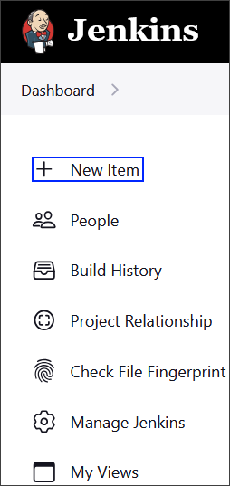
Choose Pipeline and give it a meaningful name, after that click on the [OK] button.
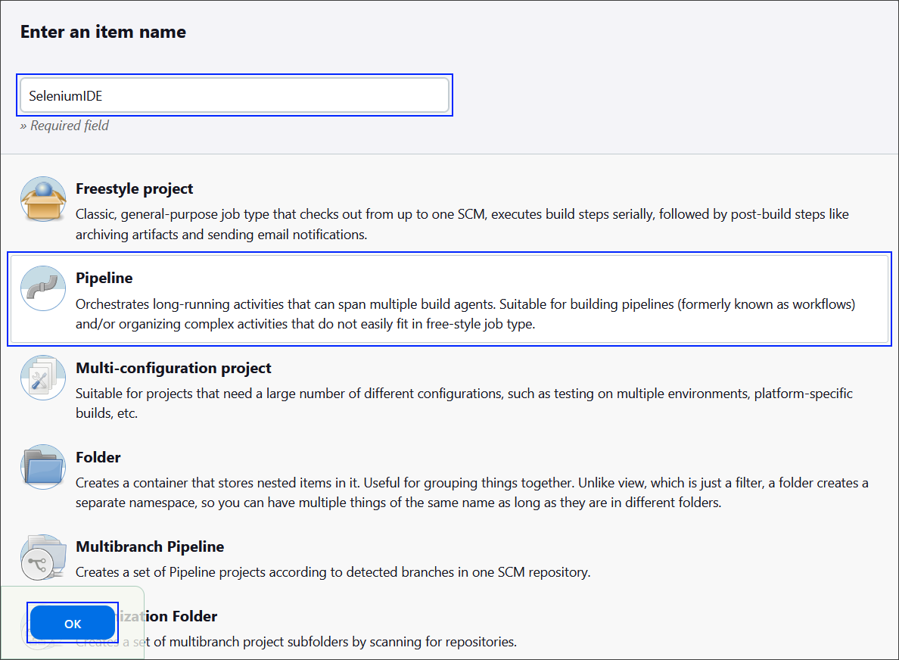

Step 6: Create the Jenkinsfile
Best practice for using a Jenkinsfile is to keep it within your source control repository.
This approach has several advantages like version control and branch specific pipelines. Placing the Jenkinsfile in the repository, means that it will be versioned alongside your application code and the versions can later be reviewed. Also, you can have different Jenkinsfile versions in different branches, which allows for testing changes to the build process in a feature branch before merging them to the main branch.
The Jenkinsfile should contain steps for:
- Checkout the code
- Set up .NET Core
- Uninstall current chrome
- Install specific version of Chrome
- Download and install ChromeDriver
- Restore dependencies
- Build
- Run tests

Pipeline Configuration
Let's start with the pipeline configuration.
We have to specify that the pipeline can run on any available Jenskins agent and declare the environmental variables to be used within it:
- CHROME_VERSION: The version of Google Chrome to be installed
- CHROMEDRIVER_VERSION: The version of ChromeDriver to be installed
- CHROME_INSTALL_PATH: The installation path for Google Chrome
- CHROMEDRIVER_PATH: The installation path for ChromeDriver
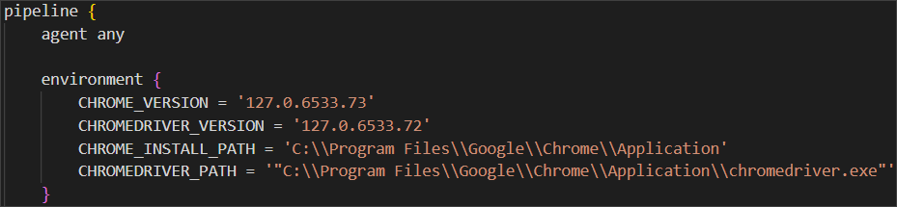

Checkout Code Stage
Next step is to define a stage for checking out the source code.
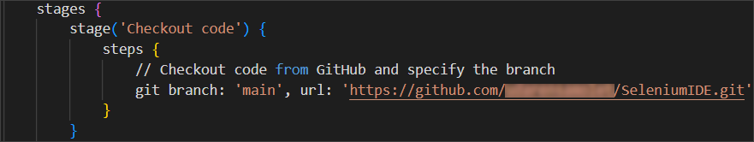

Set up .NET Core Stage
After that, we have to define the stage for setting up .NET Code SDK.
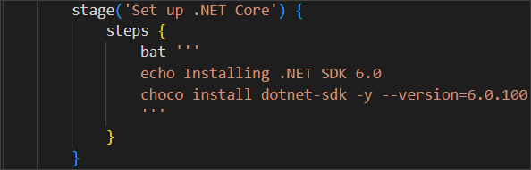

* Uninstall Current Chrome Stage
This step is optional, in case you are not sure how to install the proper Google Chrome version. 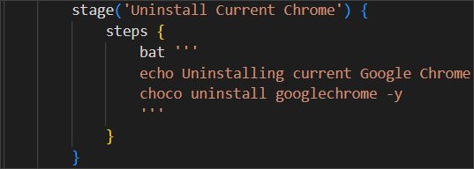

* Uninstall Current Chrome Stage
This step is optional and is used in combination with the previous step.
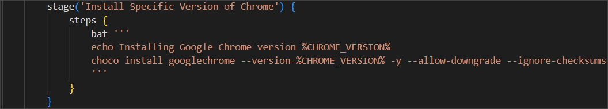

* Download and Install ChromeDriver Stage
This step is optional and is used in combination with the previous two previous steps.
Use the code below, as this is a pretty long command:
stage('Download and Install ChromeDriver') {
steps {
bat '''
echo Downloading ChromeDriver version %CHROMEDRIVER_VERSION%
powershell -command "Invoke-WebRequest -Uri https://chromedriver.storage.googleapis.com/%CHROMEDRIVER_VERSION%/chromedriver_win32.zip -OutFile chromedriver.zip -UseBasicParsing"
powershell -command "Expand-Archive -Path chromedriver.zip -DestinationPath ."
powershell -command "Move-Item -Path .\\chromedriver.exe -Destination '%CHROME_INSTALL_PATH%\\chromedriver.exe' -Force"
'''
}
}

Restore Dependencies Stage
Now we have to define a stage for restoring the project's dependencies.
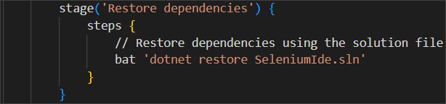

Build Stage
Now let's define a stage for building the project.
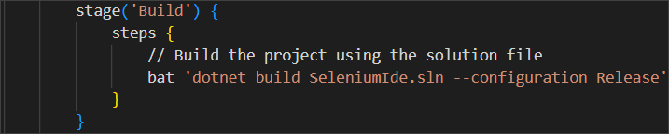

Run Tests Stage
Finally, after we have set everything needed, we can define a stage for running the tests.
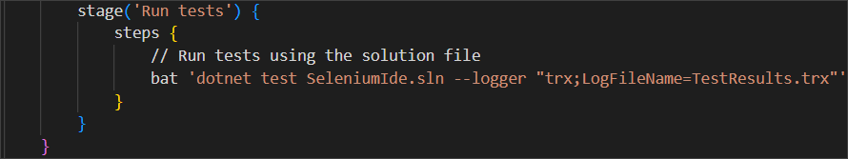

* Post Stage
This is an optional stage.
Now, let's define a post-build actions that are always executed. In our case, we will archive the test results and publish them to Jenkins.
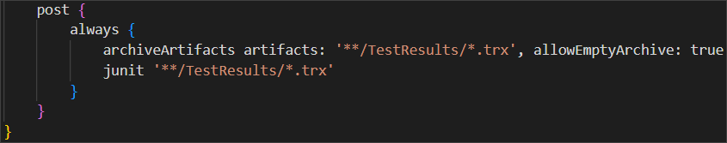
Create your file and upload it to your GitHub repository, containing the code for the application.

Step 7: Configure the Job
Now, let's go back to Jenkins to finish configuring your job.
First, in the General section give a Description for the job.
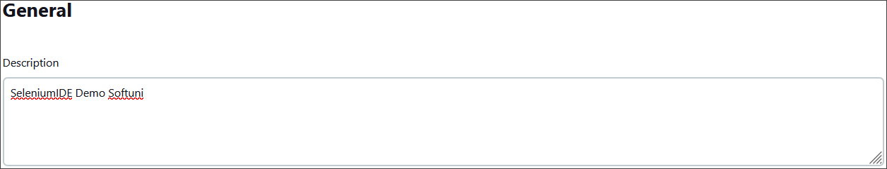
Then, scroll down to the Pipeline section in the job configuration, and from the Definition dropdown menu, select the Pipeline script from SCM option.
After that, select Git as the SCM and enter your GitHub repository URL.
Under Branches to build, enter the branch name that contains your Jenkinsfile.
Under Script Path, ensure it points to your Jenkinsfile (for example, type in Jenkinsfile if it's in the repository root).
Your configuration should look like the images below:
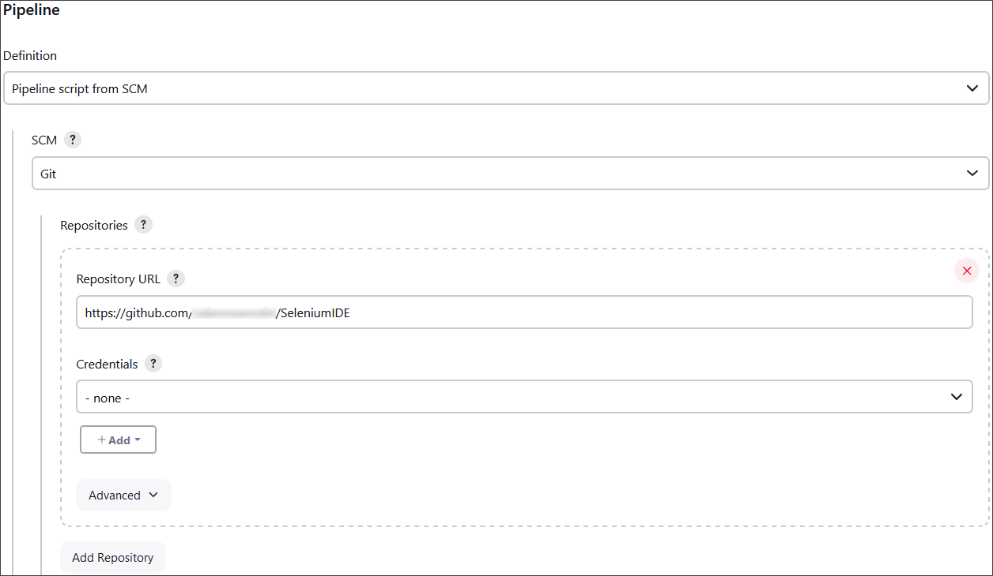
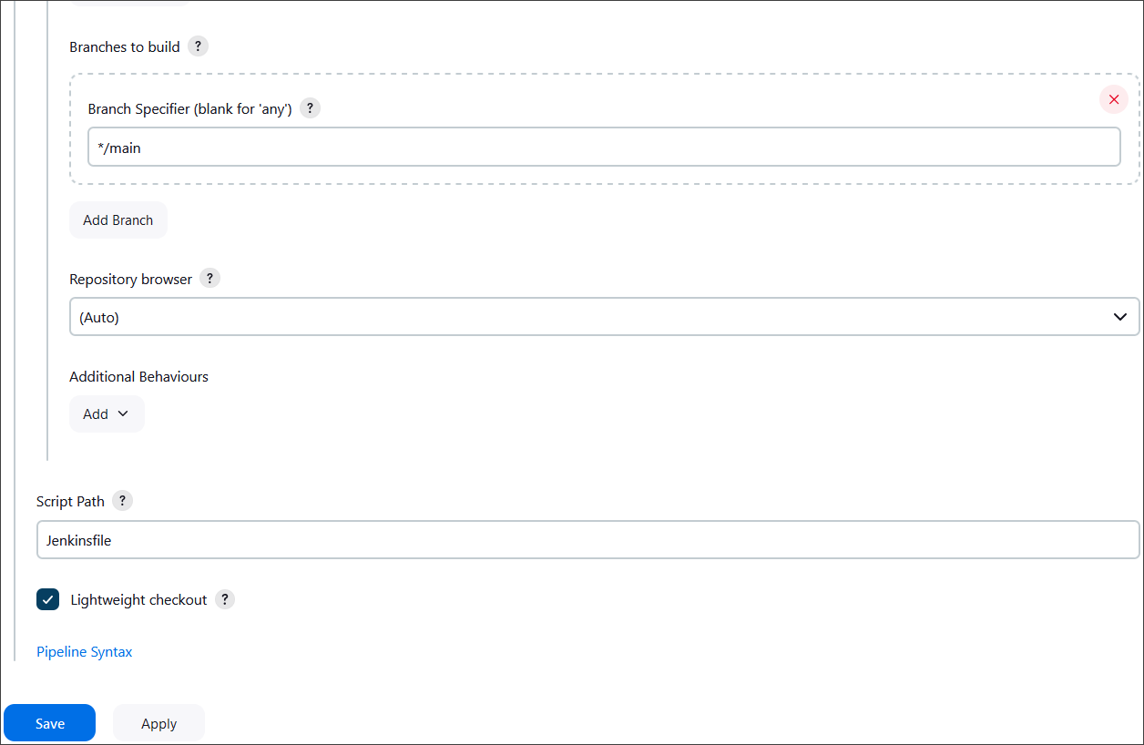
Finally, click on the [Save] button.

Step 8: Test the CI Pipeline
After completing those steps, we are ready with the CI pipeline and it's time to test if it's working as expected.
First, click on the Build Now option to start a new build manually.
You can monitor the build progress by clicking on the build number and then Console Output.
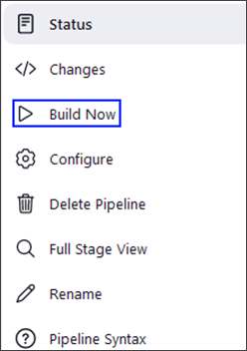
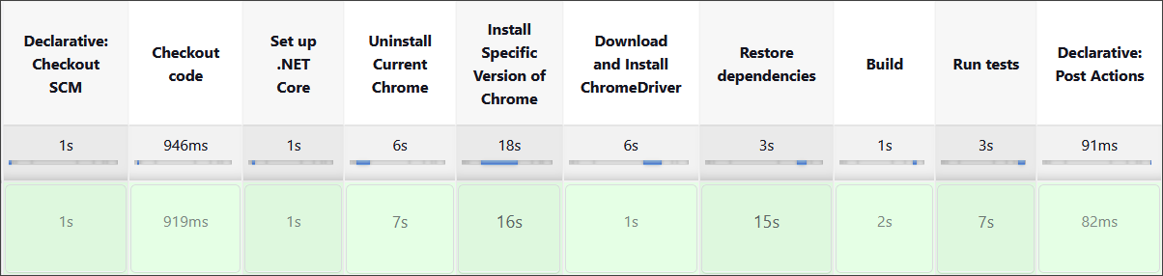

Selenium Web Driver
Our second task will be to create a CI for using Selenium to automate several test projects, combined in one solution.

Step 1: Run the App Locally
We have the "SeleniumBasicExercise" solution in the resources which has four test projects already. Your task is to create a CI workflow with GitHub Actions to run the tests automatically.
It's a good practice to build the solution locally in Visual Studio, in order to be sure everything works properly and as expected.
Open Visual Studio and from there navigate to the Tools menu. Select NuGet Package Manager and select Package Manager Console:

Let's first build the application by using the dotnet build command:
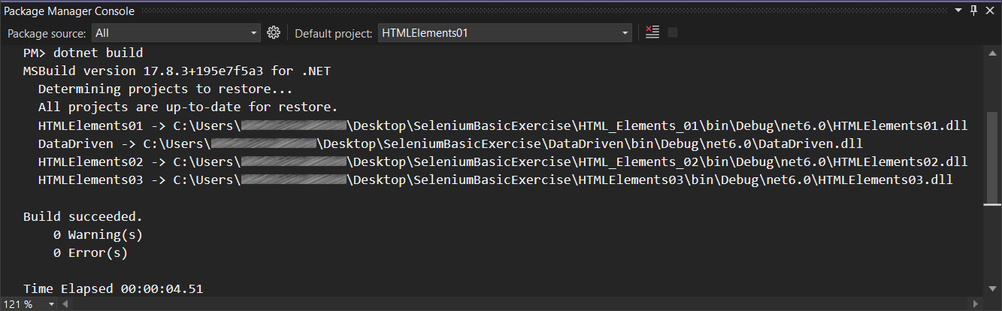
After you have ensured that the build was successful, you can run the tests, too, by using the dotnet test command or just by clicking on the [Run All Tests in View] button in the Text Explorer.
After we have ensured that the tests run successfully, we can proceed with the next step.

Step 2: Create a GitHub Repo
Now you should upload the solution to GitHub.
It's a good practice to start using the console and not the interface of GitHub, in case you haven't started doing so yet.
If you don't have Git already installed on your machine, follow the provided installation instructions from the resources.
Try using the following commands in order to initialize a repository in your project directory, add the code to the repo, commit and push:
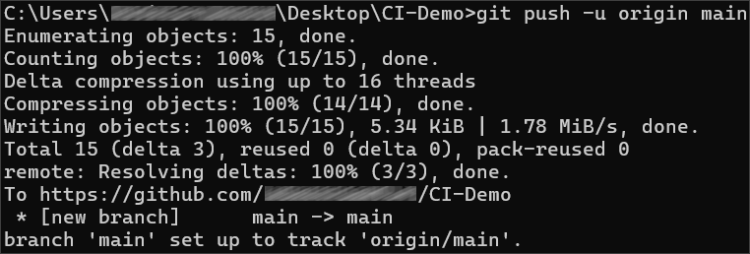
After running the commands, check you GitHub repo – the application code should be visible.

Step 3: Add Changes to Test Files
Before creating the workflow file, we have to make some adjustments in the .cs files. This is needed due to the fact that the default GitHub runner does not have Chrome installed. We will take care of this in the workflow, but we also need the prepare the tests to run Chrome in a headless mode within the CI environment.
In order to do that, go to the SetUp() method of each project and add the following code:
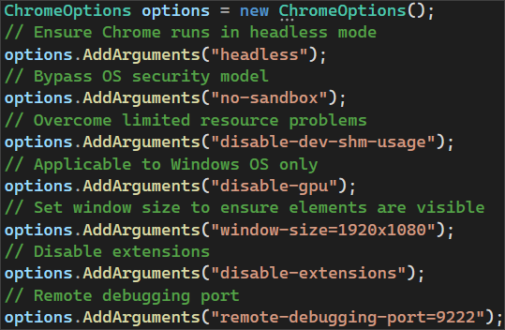
Then, we need to pass the ChromeOptions to the ChromeDriver constructor:
Don't forget to commit and push the changes to each one of the files.

Step 4: Create and Run Workflow
Now, it's time to set up the Jenkins file.
Try doing this on your own. The only difference here is that here we have to run three test projects, not just one. Think how you can achieve running the three test projects separately.

